**Chapter 7 Exercises (Advanced)**

(This exercise uses the tables and models created in chapter 4 & 5 & 6 exercise)

1. **Events**

Use event observer to acquire these:

* Whenever a customer is saved, change a customer first name to “Magenest”.
* Use model “Movie” created in Chapter 6 exercise, define “**save movie**” event, catch “**save a movie**” event, set the rating to 0 whenever a movie is saved.
* When the backend configuration is saved, if the field “Text Field” (created in Chapter 6 exercise)’s value is “Ping”, change its value to “Pong” (meaning “Pong” is saved, not “Ping”).

1. **Plugin**

Before you start:

Createa configurable product, with at least 3 options, each option is a simple product

Upload a picture for the Parent Product

Upload pictures for each Child Products (use different pictures with parent product)

See the product at frontend (E.g picture below)

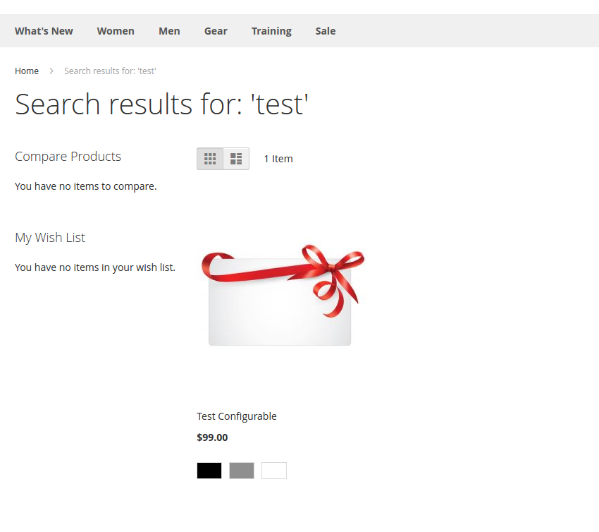(the configurable product)

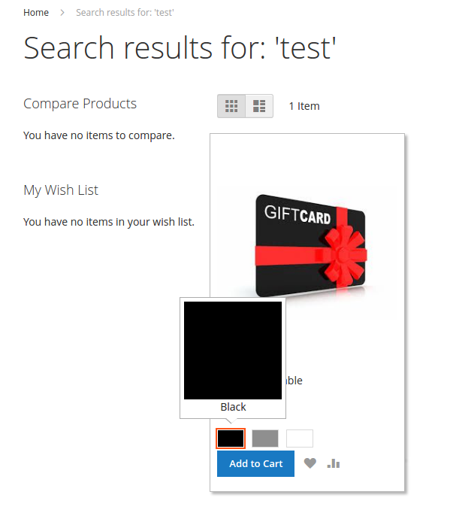Choose an option for product

After choosing an option, add product to cart (in this case, the option is: black)

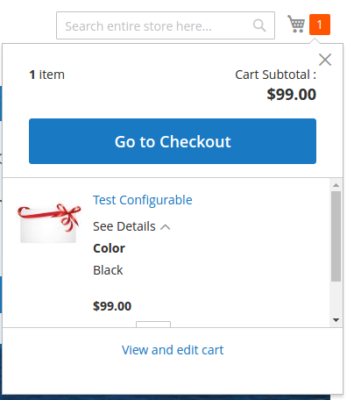

NOTICE that the option COLOR is black, but the product picture belonged to its Parent’s product

Use Plugin/Preference in Magento to acquire these:

* Change the picture above to the chosen Child Product’s picture.
* Change the product name to the chosen Child Product’s name, in this case: the name needs to be : “Test Configurable-Black”